FinTrack Prime
System Documentation
Capstone Project — Overview, User Journey & Development Approach
Prepared for panel review

1. Overview
FinTrack Prime is a personal finance management system built as a capstone project, using the banking / financial-services industry as its case study. It gives a user one place to track bank accounts and transactions, plan a budget, see their cash flow over time, and — for four specific paid tools — run loan, investment, retirement, and net-worth calculations that would otherwise live in separate spreadsheets or paid apps.
The system is aimed at an individual managing their own personal finances, not a bank or financial institution managing customers. Account balances and transactions in this system are entered by the user for demonstration purposes; they are not connected to a real bank feed, and investment prices are entered by the user rather than pulled from a live market data source.
Two tiers of functionality demonstrate the core idea of the project: a free tier (account dashboard, budget planner, cash flow view) available to every registered user, and a premium tier (four advanced planning tools) that must be purchased individually and is unlocked only after the backend independently confirms payment with PayPal — not simply because the frontend says the purchase succeeded.
2. Process and Flow
The diagram below shows how a single user moves through the system from first sign-up to using a paid tool.
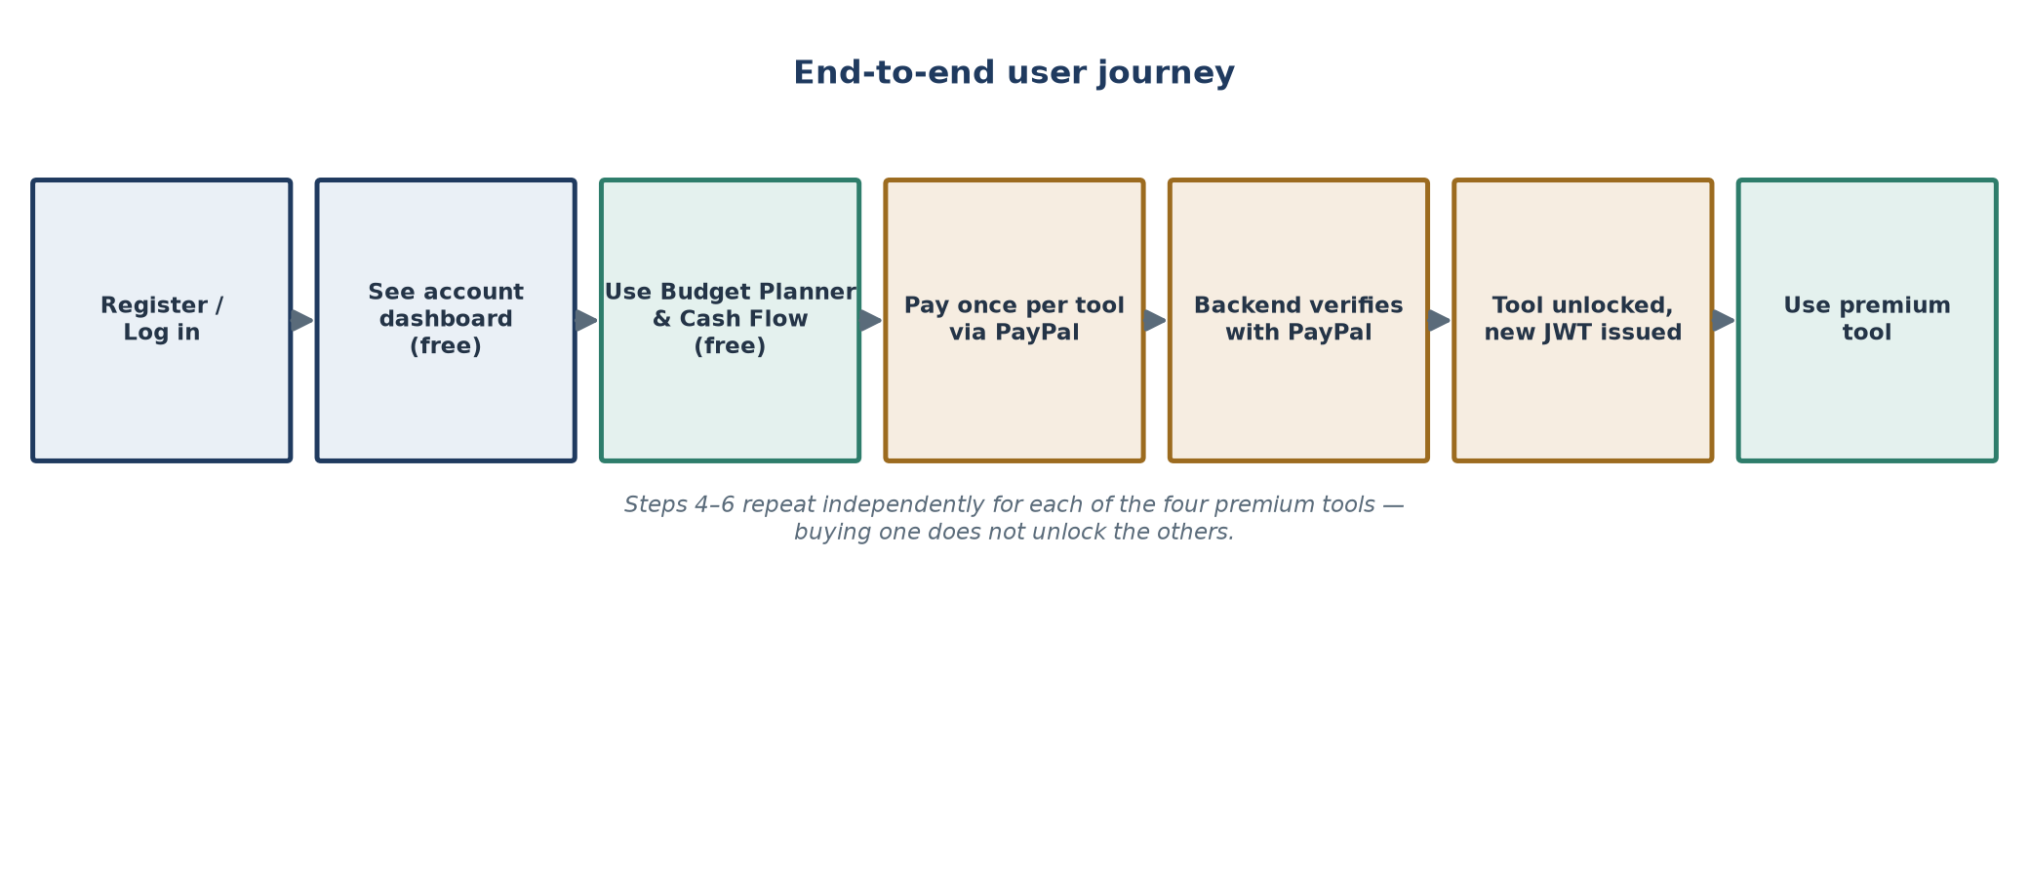
Figure 1 — End-to-end user journey.
Step by step
- Register or log in. A user creates an account with a name, email, and password, or signs in with Google. New accounts are seeded with six starter budget categories (Salary, Housing, Utilities, Groceries, Transportation, Savings) so the Budget Planner isn't a blank page on day one.
- See the account dashboard (free). The user can add bank accounts and record transactions. The dashboard shows recent activity per account and flags any expense that looks like an unusual outlier compared to that account's own history — a simple statistical rule, not machine learning.
- Use the Budget Planner and Cash Flow view (free). These are two different views over the same transaction data: one compares planned vs. actual by category, the other shows income/expense totals and a month-by-month trend.
- Pay for a premium tool via PayPal. Each of the four premium tools — Loan Calculator, Investment Tracker, Retirement Planner, Financial Statement — is purchased separately, one PayPal payment per tool.
- The backend verifies the payment with PayPal directly. It does not trust the frontend's word that payment succeeded; it independently asks PayPal for the order's real status and amount before granting anything.
- The tool is unlocked and a new access token is issued reflecting it, so the user can start using that tool immediately without logging out and back in.
- Use the premium tool. Buying one tool does not unlock the other three — each is gated independently, so steps 4–6 repeat separately for every additional tool the user wants.
Session handling, in plain terms
A logged-in session is kept alive with two tokens working together: a short-lived access token (15 minutes) used on every request, and a longer-lived refresh token (30 days) stored in a secure browser cookie that silently obtains a new access token when the old one expires — without asking the user to log in again. If that refresh process ever detects a token being reused after it was already replaced (a sign of a stolen session), the entire session is shut down and the user must log in again. Logging out revokes only that one session, so a user signed in on two devices can log out of one without affecting the other.

3. How Claude Code Assisted in Building This System
This backend was built in four phases, each adding one complete vertical slice of functionality rather than building every layer for every feature at once. Claude Code was used throughout as a pair-programming assistant: scaffolding each new layer (interfaces, services, controllers, and DTOs) in a way consistent with the architecture already in place, wiring up the corresponding Entity Framework Core migration, and reviewing security-sensitive logic before moving on to the next phase.
Phase 1 — Foundation and authentication
The first phase established the three-project structure and the core authentication system: user registration, login, password hashing, JWT issuance, and the account dashboard. Every later phase builds on this same foundation rather than introducing a parallel one.
Phase 2 — Free tools
With authentication in place, the Budget Planner and Cash Flow Dashboard were added as the system's free tier — both built as different views over the same transaction data already captured in Phase 1, rather than introducing a separate data model.
Phase 3 — Payment verification
This phase connected a real, server-verified PayPal payment to the act of unlocking access — replacing any notion of trusting the frontend's claim that a payment succeeded with an independent, server-to-server check against PayPal's own API before a purchase is ever recorded.
Phase 4 — Premium tools
With verified payment in place, the four premium tools — Loan Calculator, Investment Tracker, Retirement Planner, and Financial Statement generator — were built one at a time, each gated behind its own independent per-tool authorization check rather than a single shared "premium" flag.
Working style: at each phase, Claude Code was used to scaffold new code consistent with the existing layering, and to review the previous phase's security-sensitive logic (password handling, token handling, payment verification) before building on top of it.

4. Preparations Before and During Development
Planning the architecture upfront
Before any feature code was written, the three-project split (Models / Business / WebApi) and the rule that each layer only depends on the one below it were decided as the foundation the rest of the project would build on. That upfront decision is what let each of the four phases add a complete new slice of functionality without restructuring what came before.
Aligning the case study to the banking industry
The feature set — bank accounts, transactions, budgeting, cash flow, retirement planning, and net worth — was chosen specifically to mirror functions found in banking and financial-services products, so the capstone case study would read as a believable fintech application rather than a generic CRUD demo.
Setting up the PayPal Sandbox environment
A PayPal Developer sandbox application was set up to provide sandbox client credentials, so the full purchase-and-verify flow could be tested end-to-end without moving real money. The API base URL is configured to PayPal's sandbox host during development, with production deployment only requiring that one value to be swapped to PayPal's live host.
Verifying each phase before moving on
Each phase's endpoints were exercised through the built-in Swagger UI as they were completed, so problems in one phase's foundation were caught before the next phase was built on top of it.
5. Scope Boundaries
For clarity in front of a panel, the following are explicitly outside this backend's current scope:
- The frontend application itself — this document covers the backend API only.
- Real bank connectivity — account balances and transactions are entered by the user for demonstration.
- Live market data — investment holding prices are entered by the user, not pulled from a market feed.
- Email verification and password-reset flows — neither currently exists.

